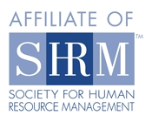

June 14, 2012 Meeting Notice
Flathead Valley Chapter of SHRM
(Society for Human Resource Management)

Date: Thursday, June 14, 2012
Time: 11:45 a.m. to 1:15 p.m.
Place: The Summit, 205 Sunnyview Lane, Conference Room #3, Kalispell
Lunch: Lunch is $10 per member, $20 for program & lunch for non-members.
Note: If you RSVP a lunch request and are unable to attend, you will be billed for the lunch.

If you plan to attend, please RSVP by 5:00 p.m. on Tuesday June 12, 2012 to cindy.carpenter@nfs.stoneriver.com. We look forward to seeing you. Thank you.

Please advise if you wish to order lunch or not when you RSVP

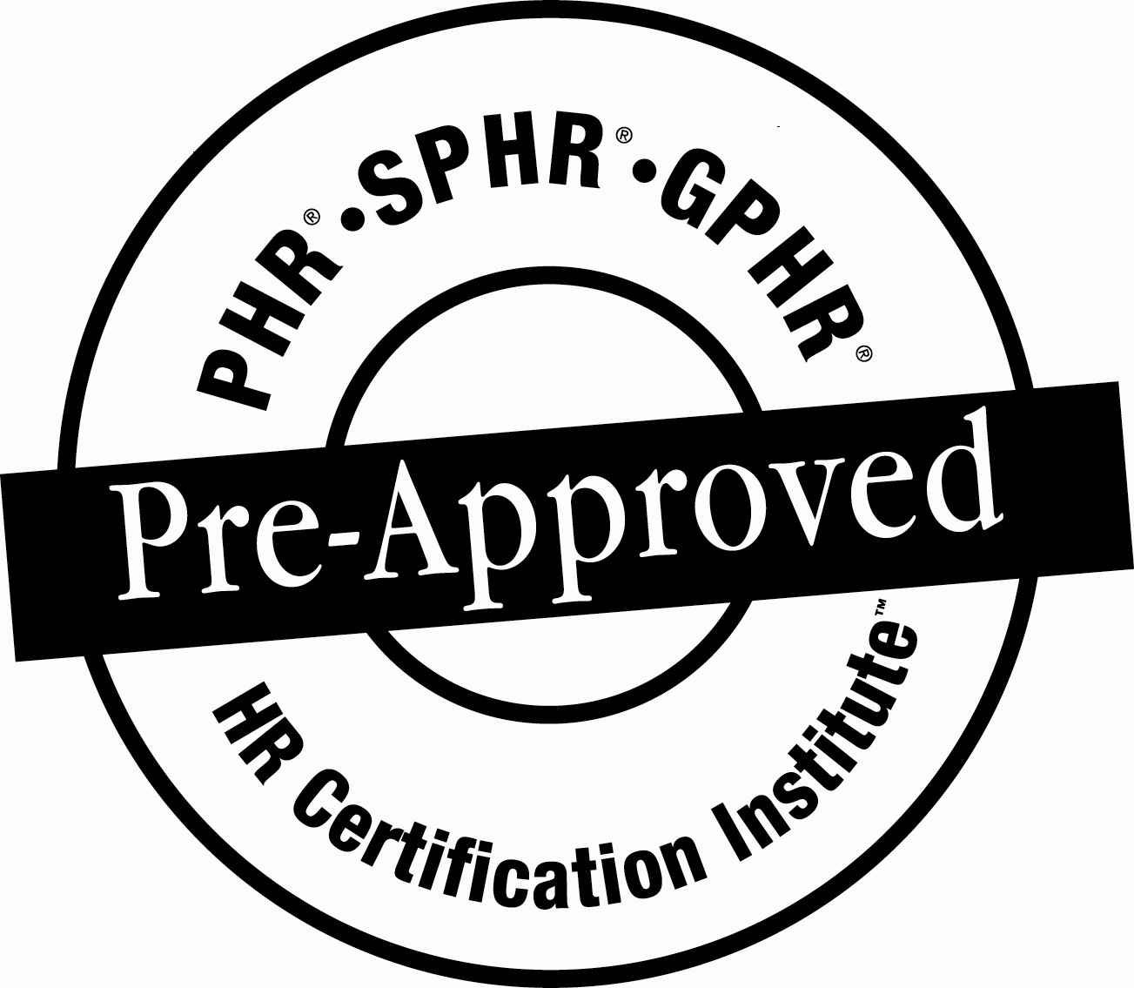

Program: Business Civility – The Three “C’s” – Civility, Communication and Character
Diana Damron (www.dianadamron.com) is devoted to bringing civility back to our professional personal communication. By rediscovering what ‘civility’ truly is and how to exercise it, Diana ensures we will see remarkable results at work and at home. The focus will be on the three “C’s”: Civility, Communication and Character. For this meeting, she will zero in on civility, she will underscore that the three “C’s” are interdependent and interwoven as a personal tapestry. Diana will describe the rewards of focusing on civility and the costs (both monetarily and professionally) of ignoring it.

Presenter:
Diana Damron (www.dianadamron.com) is a personal and professional coach and consultant. She brings a diverse background and expertise to the profession as a former model, as well as a television anchor and reporter. She knows the impact of communication skills. According to Diana, it is not just about the word we speak. Her insight comes not only from a professional point of view, but also as a mother who lived with her family in a foreign country. All of her experiences have shaped a perspective that zeros in on the fundamentals of civility, communication and character. She brings humor and humility to her presentations as well. After all, this is a woman (hard to miss at nearly six feet tall) who walked off the runway at a national modeling competition at the Waldorf Astoria Hotel in New York City.

We encourage Flathead Valley Chapter members to bring guests to our monthly meetings to experience first hand, the benefit of SHRM. Members who bring guests will have an opportunity to win a lunch redeemable at a future meeting.

Support the SHRM Foundation and yourself — buy “Split the Pot” tickets! YOU could win money and/or lunch!
*The use of this seal is not an endorsement by the HR Certification Institute of the quality of the program. It means that this program has met the HR Certification Institute’s criteria to be pre-approved for recertification credit.
Visit our website at http://flatheadshrm.org
Join our LinkedIn group:
http://www.linkedin.com/groups/SHRM-Flathead-Valley-Kalispell-Montana-4286381?trk=myg_ugrp_ovr.

